COVID-19 Research Recovery Plan: Animal-Based Research
In alignment with the most recent memo from the VPR to your unit leader (May 28th, 2020), the recovery of animal-based science activities will be based upon a phased approach involving the following specific criteria and approval processes:

Phase-Specific Criteria for Reactivation of Animal-Based Activities
Adjudication of requests for reactivation of animal-based research will be based upon the following phase-specific criteria.
Please note that the continuance and activation of any experimental animal procedures is contingent upon the availability of staff and associated materials. In the event that resources are insufficient, procurement and procedures will be reviewed and possibly required to be ceased. This will be determined in part by the availability of animal health professionals and/or competent research staff as well as public health and Institutional directives.

Phase 1
Based on available support from Animal Care and Veterinary Services, approval for animal-based science has been subject to pre-approval by the ACC-Crisis Response Team (CRT) based upon alignment with the following criteria and contingent upon operational capacities and institutional directives:
- COVID-funded/approved research;
- Breeding priority 1 and 2 strains (per Strains Inventory exercise) for replacement of breeding stock or intermediate strains to achieve priority 1 and 2 strains;
- Chronic on-going longitudinal studies (started prior to any recovery) that have been approved by the ACC-CRT, and are now time critical (manuscript/grant/grad thesis figure preparation);
- Other studies that were put on hold between March and May that have been approved by the ACC-CRT, and are now time critical (manuscript/grant/grad thesis figure preparation) with significant investments represented, but do not include a survival surgery, i.e. acute or short-term non-invasive studies; and
- Field study animal captures, as approved by the VPR.

Phase 2-4
Please see the decision tree to the right for details on the process to be followed during the following phases.
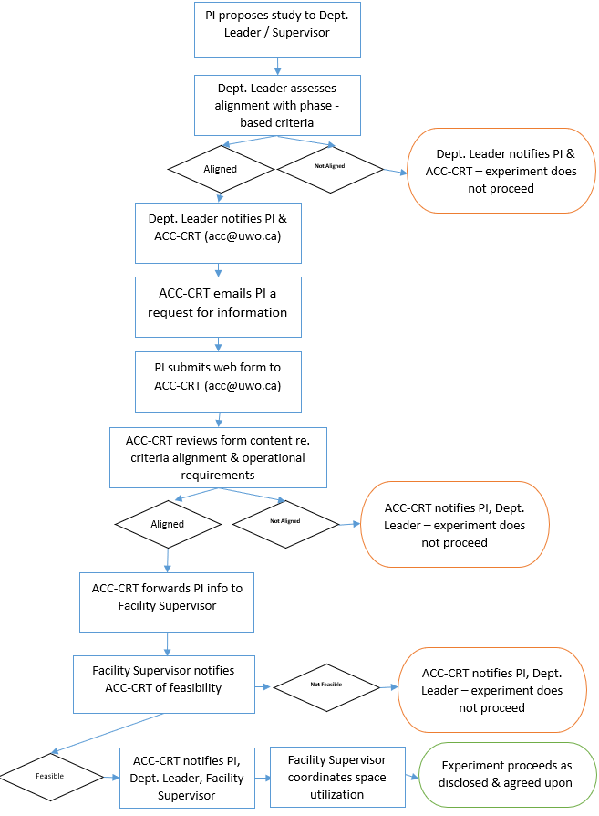

Phase 2
At this stage research capacity will be at ~20% at any given time, and will involve a two-tiered approval process, as outlined in the decision tree. The Dean / Department Head will notify the ACC-CRT of their pre-approval based upon the criteria below in order to assess its feasibility with respect to citywide operational capacity. The ACC-CRT will email the PI directly requesting further information. Once ACC-CRT approval is granted, the PI, Dean / Department Head will be notified.
Approval will be based upon priority sequence in alignment with the following criteria and contingent upon operational capacities and institutional directives:
- Breeding of priority 1 strains for the production of experimental animals, or of intermediate strains to achieve priority 1 or 2 strains;
- For non-mouse/rat species, breeding to generate additional experimental studies/animals will take into account species gestational period
- Studies that were put on hold between March and May and are now time critical (manuscript/grant/grad thesis figure preparation) with significant investments represented, and do include survival surgery;
- Studies that were scheduled to be undertaken at this time that are now time critical, with and without survival surgery; and
- animal procurement for new short-term studies on existing AUPs and newly approved Modifications.

Phase 3
At this stage research capacity will be at ~40% at any given time, and will involve a two-tiered approval process, as outlined in the decision tree. The Dean / Department Head will notify the ACC-CRT of their pre-approval based upon the criteria below in order to assess its feasibility with respect to citywide operational capacity. The ACC-CRT will email the PI directly requesting further information. Once ACC-CRT approval is granted, the PI, Dean / Department Head will be notified.
Approval will be based upon priority sequence in alignment with the following criteria:
- Studies continue, as per Phase 2; and
- Breeding of priority 2 strains for the production of experimental animals and where necessary, procurement of breeding replacements for priority 2 strains.

Phase 4
At this stage research capacity will be at ~60% at any given time, and will involve a two-tiered approval process, as outlined in the decision tree. The Dean / Department Head will notify the ACC-CRT of their pre-approval based upon the criteria below in order to assess its feasibility with respect to citywide operational capacity. The ACC-CRT will email the PI directly requesting further information. Once ACC-CRT approval is granted, the PI, Dean / Department Head will be notified.
Approval will be based on priority sequence in alignment with the following criteria, and contingent upon operational capacities and institutional directives, as outlined in the decision-tree:
- normal colony breeding processes;
- animal procurement for on-going studies;
- animal procurement for new studies on existing AUPs, new AUPs and newly approved Modifications; and
- studies that were placed on hold – including non-critical – with and without survival surgery.
We continue to partner with you during the phased recovery of animal-based science activities throughout Western and Lawson.
Should you have any questions or concerns, feel free to contact us at <a href="mailto:acc@uwo.ca">acc@uwo.ca</a>.
Regards,
The ACC-CRT

